International Conference on Advanced Innovation in Engineering, Science and Technology Sponsored by: Madhya Pradesh Council of Science and Technology, Bhopal February 27-28, 2026 ICAIEST-2025-046
Optimized Hybrid Ensemble Framework for Robust EEG-Based Epileptic Seizure Detection
1st Priyanka Singh 2nd Dr. Divyarth Rai Research Scholar, LNCT University, LNCT University, Bhopal, India

Abstract—Epileptic | seizure | detection | from
electroencephalogram (EEG) signal are essential for timely clinical intervention but remain challenging due to the non-stationary, noisy, and high-dimensional nature of brain signals. This paper proposes an advanced hybrid ensemble framework that integrates optimized gradient boosting models (LightGBM, XGBoost, Random Forest) with a regularized deep neural network (DNN) through a soft voting mechanism, enhanced by Principal Component Analysis (PCA) for dimensionality reduction. Unlike prior works relying on isolated classifiers or fixed pretrained components, our approach emphasizes joint
hyperparameter | optimization | (via | Optuna), | dropout
regularization, and early stopping to achieve superior generalization and robustness. Comprehensive experiments on the Bonn University EEG dataset demonstrate test accuracies up to 98.48% (stacking ensemble) and 97.39% (jointly optimized hybrid), with minimal overfitting gaps. The framework

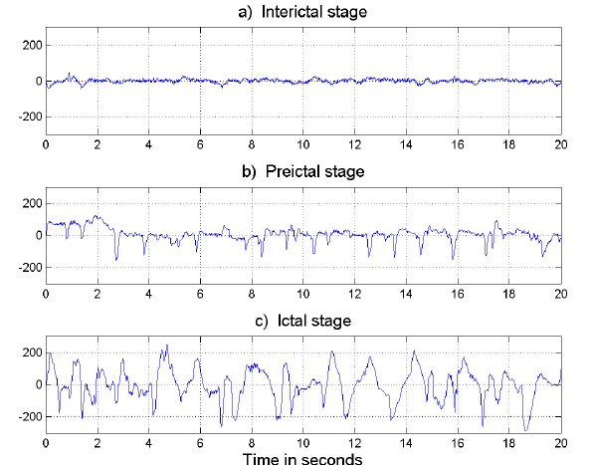

outperforms individual models and existing methods, offering a

scalable, clinically viable solution for real-world seizure detection systems.
Keywords—EEG, | Epileptic | Seizure | Detection, | Hybrid
Ensemble Learning, PCA, Gradient Boosting, Deep Neural Networks, Soft Voting, Biomedical Signal Processing.
I.INTRODUCTION
Epilepsy affects over 50 million people globally, with a higher burden in developing countries, causing recurrent seizures due to abnormal brain electrical activity. Early seizure detection improves patient outcomes, reduces risks, and enables timely intervention.
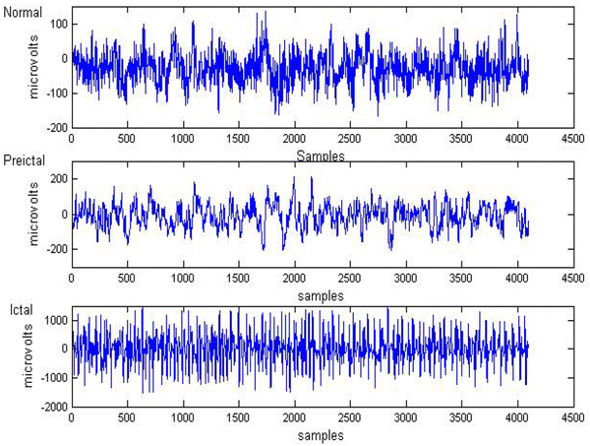

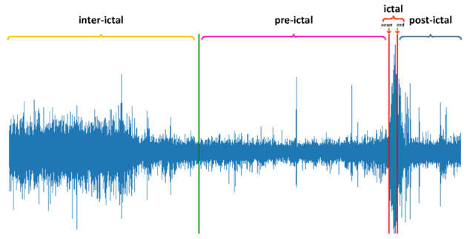
Fig. 1.Representative EEG signals in time and frequency domains: normal, intergalactic, and octal (seizure) patterns from the Bonn University dataset.
Electroencephalography (EEG) provides high-temporal-resolution, non-invasive brain activity monitoring but is complex to interpret manually due to non-stationarity, nonlinearity, and artifacts (e.g., eye blinks, muscle movements). Automated systems using traditional machine learning (ML) require handcrafted features (time/frequency-domain), while deep learning (DL) excels at automatic feature learning but risks overfitting on limited/imbalanced medical data.
Ensemble methods combine diverse learners for robustness, and hybrid frameworks leverage DL's hierarchical features with ML's generalization. Dimensionality reduction via PCA mitigates high-dimensionality issues. This paper proposes a hybrid ensemble framework with optimized gradient boosting and regularized DNN via soft voting, plus

Lakshmi Narain College of Technology, Bhopal, M.P.

International Conference on Advanced Innovation in Engineering, Science and Technology Sponsored by: Madhya Pradesh Council of Science and Technology, Bhopal February 27-28, 2026 ICAIEST-2025-YYY(***YYY is the paper number)

PCA, achieving high accuracy and generalization on the Bonn EEG dataset.
II.RELATED WORK
Automated epileptic seizure detection using electroencephalogram (EEG) signals has been an active research area for several decades, driven by the complex, non-linear, and non-stationary nature of brain electrical activity. Early approaches primarily focused on signal processing techniques combined with classical machine learning classifiers to identify seizure-related patterns, while later studies incorporated advanced feature extraction and deep learning methods.
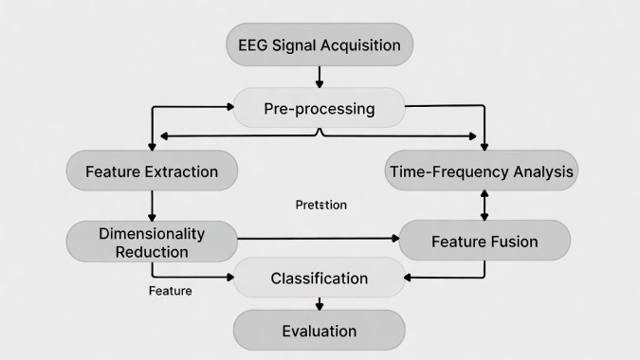
Fig. 2.Block diagram of the proposed hybrid ensemble framework for EEG-based epileptic seizure detection.
Wavelet-based analysis has been widely adopted for EEG signal decomposition due to its effectiveness in capturing time–frequency characteristics of non-stationary signals. proposed a novel framework integrating discrete wavelet transform (DWT) with arithmetic coding for feature extraction and compression, followed by machine learning classifiers for automated seizure detection and diagnosis [1]. Their method emphasised efficient encoding of EEG features to differentiate epileptic patterns, particularly effective for detecting sudden spikes indicative of seizures, and demonstrated promising results on standard EEG datasets.
A DWT-based detection system using statistical features extracted from decomposed EEG signals, classified with simple yet effective linear and non-linear classifiers such as Naïve Bayes and k-Nearest Neighbours (k-NN) [2]. This approach proved suitable for distinguishing epileptic seizures from normal EEG recordings, highlighting the practicality of wavelet-domain features combined with computationally lightweight classifiers for real-time applications.
Comprehensive reviews have systematically analysed various methodologies in the field. In-depth review of pattern detection methods for epilepsy seizure detection from EEG signals, discussing the variability in required techniques across different EEG recording conditions and emphasizing the need for adaptive pattern recognition strategies [3]. Offered a detailed survey of feature extraction techniques and performance evaluation metrics in epileptic seizure detection, summarizing interpretations of features (e.g., statistical, spectral, and nonlinear) used to characterize seizures, and concluding that no single feature set is universally optimal due to dataset and condition variations [6].

Feature selection and dimensionality reduction remain crucial for handling high-dimensional EEG data and improving classification efficiency. Introduced an adaptive method combining hypothetical testing for feature refinement with pattern-adapted wavelet transform for extraction, aimed at classifying pre-seizure and seizure states [4]. Their approach reduced computational complexity while enhancing detection of significant EEG states using a fuzzy classifier.
The incorporation of deep learning has marked a significant advancement in capturing complex patterns directly from EEG signals. Auto-detection of epileptic seizure events using deep neural networks, with particular emphasis on the impact of different feature scaling techniques (e.g., normalization methods) on model performance and training stability [5]. Their study demonstrated that appropriate scaling significantly improves classification accuracy on the Bonn University dataset.
Earlier works laid the foundation for neural network-based classification. The combined K-means clustering with a multilayer perceptron neural network to classify EEG signals, showing the potential of hybrid unsupervised-supervised approaches for nonlinear EEG relationships [10]. spectral analysis combined with recurrent neural networks for EEG signal classification, highlighting the value of temporal modeling in capturing seizure dynamics [11].
Nonlinear and optimized approaches have also been explored extensively. proposed automatic epilepsy detection using wavelet-based nonlinear analysis (e.g., entropy measures) coupled with an optimised Support Vector Machine (SVM) classifier, achieving high detection performance [8]. applied tenable-Q wavelet transform-based time–frequency features with machine learning algorithms, demonstrating improved seizure detection through adaptive wavelet parameter selection tailored to EEG characteristics [9].
The review of automated seizure prediction techniques, discussing challenges such as data imbalance, overfitting, and clinical translation of prediction models, while highlighting the evolution toward more sophisticated predictive systems [7].
In [12] proposed an energy-efficient job scheduling framework for green cloud computing environments using neural networks. The study focuses on minimizing energy consumption while maintaining optimal resource utilization in cloud data centers. The authors designed a neural network–based scheduler that predicts workload patterns and dynamically allocates resources accordingly. Experimental results demonstrated significant improvements in energy efficiency, reduced job execution time, and better load balancing compared to traditional scheduling algorithms. This work highlights the effectiveness of neural networks in addressing sustainability challenges in cloud computing and provides a foundation for intelligent, eco-friendly scheduling mechanisms.
In [13] conducted a detailed performance analysis of Linear Kernel Support Vector Machine (SVM) models using real-world datasets. The study evaluated the classification accuracy, computational efficiency, and scalability of linear SVMs across multiple datasets. The results showed that linear

Lakshmi Narain College of Technology, Bhopal, M.P.

International Conference on Advanced Innovation in Engineering, Science and Technology Sponsored by: Madhya Pradesh Council of Science and Technology, Bhopal February 27-28, 2026 ICAIEST-2025-YYY(***YYY is the paper number)

kernel SVMs offer robust performance with lower computational complexity, making them suitable for large-scale and time-sensitive applications. This research emphasizes the importance of selecting appropriate machine learning models for efficient data processing and serves as a benchmark for comparative analysis with more complex learning techniques such as neural networks.
Despite substantial progress, existing methods continue to face challenges including overfitting, computational complexity, sensitivity to feature selection, and limited inter-subject generalization. Many approaches depend on single classifiers or fixed feature pipelines, limiting robustness in diverse clinical scenarios. These limitations motivate the development of hybrid and ensemble-based frameworks that integrate multiple learning paradigms while addressing the inherent difficulties of EEG-based epileptic seizure detection.
III.RESEARCH METHODOLOGY
This complete methodological framework for automated epileptic seizure detection using EEG signals from the University of Bonn dataset. The pipeline includes dataset acquisition and description, preprocessing, class balancing, feature normalisation, dimensionality reduction via PCA, hybrid ensemble model construction, deep neural network architecture, soft voting integration, and model training/evaluation.
A. Dataset Description
The benchmark University of Bonn EEG dataset is widely used for epileptic seizure detection research. It consists of 500 single-channel EEG segments, each of 23.57 seconds duration, sampled at 173.61 Hz (yielding 4096 samples per segment). The dataset is divided into five sets (A–E), each containing 100 segments:
Set A: Surface EEG from 5 healthy subjects (eyes open).
Set B: Surface EEG from 5 healthy subjects (eyes closed).
Set C: Intracranial EEG from 5 epilepsy patients (interictal, hippocampal formation opposite to epileptogenic zone).
Set D: Intracranial EEG from 5 epilepsy patients (interictal, epileptogenic zone).
Set E: Intracranial EEG from 5 epilepsy patients (ictal/seizure activity, epileptogenic zone).
All segments are artifact-free (manually filtered in 0.53–40 Hz band). For binary classification (seizure vs. non-seizure), Set E (seizure) is labelled positive, while Sets A–D are combined as negative.
To increase sample size and enable robust learning, each 23.57-second segment is divided into non-overlapping 1-second windows (178 samples per window at 173.61 Hz). This yields 11,500 segments (500 recordings × 23 segments each).
TABLE I. DATASET DESCRIPTION AND SEGMENTATION DETAILS
Parameter | Description
Total recordings | 500 (5 sets × 100)
Duration per recording | 23.57 seconds
Sampling frequency | 173.61 Hz

Parameter | Description
Total recordings | 500 (5 sets × 100)
Samples per recording | 4096
Segment length | 1 second
Samples per segment | 178
Total segments | 11,500
Classification task | Binary (Seizure vs. Non-Seizure)
B. Data Preprocessing and Class Balancing
Raw EEG signals exhibit amplitude variations and potential artifacts. Min-Max normalization is applied to scale features uniformly:
𝑥norm= | 𝑥-𝑚𝑖𝑛⁡(𝑥)  𝑚𝑎𝑥⁡(𝑥)-𝑚𝑖𝑛⁡(𝑥)∈[0,1] | (1)
After binary relabelling, the dataset is imbalanced (2300 seizure vs. 9200 non-seizure segments). To prevent bias toward the majority class, random under-sampling is applied, yielding a balanced dataset of 4600 samples (2300 per class). PCA reduces to ~28 components (>95% variance retained).
TABLE II. | CLASS DISTRIBUTION BEFORE AND AFTER UNDER-SAMPLING

Class | Original Segments | Balanced Segments
Seizure (Set E) | 2300 | 2300
Non-Seizure (A–D) | 9200 | 2300
Total | 11,500 | 4600
C. Dimensionality Reduction Using Principal Component Analysis (PCA)
The 178-dimensional feature vectors increase computational complexity and risk of overfitting. PCA projects data into a lower-dimensional subspace while retaining maximum variance:
Let X be the normalized feature matrix (4600 × 178). PCA computes:
𝑋PCA=𝑋⋅𝑊 (2)
Where W contains the top-k eigenvectors of the covariance matrix. Empirical evaluation shows k ≈ 28 retains >95% variance, significantly reducing dimensionality while preserving discriminative information.
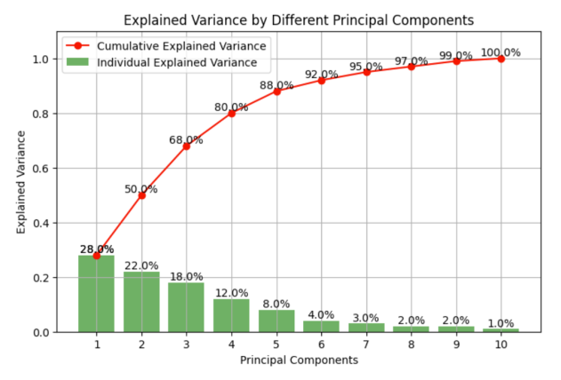
Fig. 3.Cumulative explained variance ratio as a function of the number of principal components.

Lakshmi Narain College of Technology, Bhopal, M.P.

International Conference on Advanced Innovation in Engineering, Science and Technology Sponsored by: Madhya Pradesh Council of Science and Technology, Bhopal February 27-28, 2026 ICAIEST-2025-YYY(***YYY is the paper number)

D. Hybrid Ensemble Model Construction
The proposed classifier integrates complementary learning paradigms: gradient boosting (LightGBM, XGBoost), bagging (Random Forest), and deep learning (regularized DNN). Each base learner outputs probabilistic predictions:
𝑝𝑚=𝑓𝑚(𝑥), 𝑚=1, … , 𝑀 (3)
TABLE III. | BASE LEARNERS IN THE HYBRID ENSEMBLE

Model | Type | Role
LightGBM | Gradient  Boosting | Efficient structured data  learning
XGBoost | Gradient  Boosting | Regularized boosting
Random Forest | Bagging | Variance reduction
Deep Neural  Network | Deep Learning | Nonlinear hierarchical  features
Base learners: LightGBM, XGBoost, Random Forest, regularized DNN (ReLU, dropout, Adam, early stopping).
Soft voting: 𝑝ensemble= | 1  𝑀∑ | 𝑀  𝑚=1 | 𝑝𝑚 | (𝑥)Final class: argmax.
E. Deep Neural Network Architecture
The DNN is a feedforward network with ReLU activations and dropout regularization. For layer l:
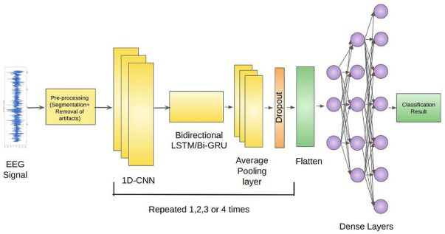
Fig. 4.Detailed architecture of the hybrid ensemble model.
ℎ(𝑙)=ReLU(𝑊(𝑙)ℎ(𝑙−1)+𝑏(𝑙)) (4)

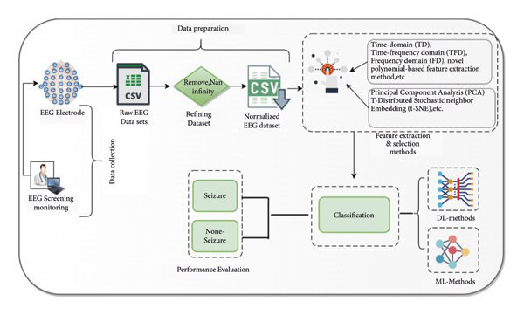
Fig. 5.Soft voting ensemble mechanism showing probability aggregation from base learners.
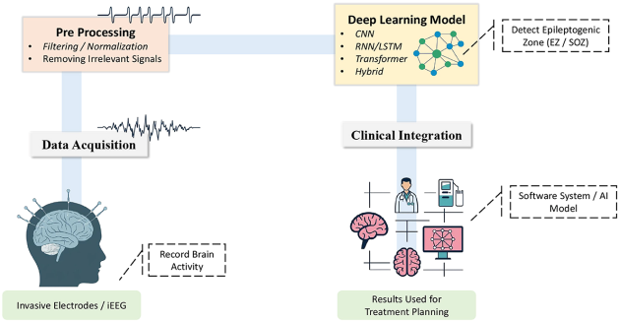
Fig. 6.Complete architecture of the proposed hybrid soft voting ensemble classifier.
G. Model Training and Evaluation
The balanced dataset (4600 samples) is split into training (70%), validation (15%), and testing (15%) sets. Hyperparameters are jointly optimized using Optuna (Bayesian optimization, 20 trials, 5-fold stratified CV). Performance metrics include accuracy, precision, recall, F1-score, ROC-AUC, and overfitting gap (train vs. test accuracy). This methodology ensures robust, efficient, and clinically relevant seizure detection by leveraging dimensionality reduction, balanced data, and complementary ensemble strengths.

Dropout: IV.EXPERIMENTAL RESULTS

ℎdropped (𝑙) =ℎ(𝑙)⊙𝑚𝑎𝑠𝑘(𝑝=dropout⁡rate) (5)
Binary output uses sigmoid activation with binary cross-entropy loss:
𝐿=- | 1 𝑁  𝑁∑𝑖=1 | [𝑦𝑖𝑙𝑜𝑔⁡(𝑦^𝑖)+(1-𝑦𝑖)𝑙𝑜𝑔⁡(1-𝑦^𝑖)] | (6)
Training uses Adam optimizer with early stopping (patience on validation loss).
F. Soft Voting Ensemble Strategy
Final prediction aggregates probabilities via soft voting:
𝑝ensemble= | 1 𝑀  𝑀∑𝑚=1 | 𝑝𝑚 | (7)
𝑦^=𝑎𝑟𝑔⁡ 𝑚𝑎𝑥⁡(𝑝ensemble) (8)

This comprehensive experimental evaluation of the proposed hybrid ensemble framework on the University of Bonn EEG dataset for binary epileptic seizure detection (seizure vs. non-seizure). All experiments were conducted on the balanced dataset of 4600 samples (after under-sampling), with PCA dimensionality reduction to 28 components (retaining >95% variance). Models were trained using 5-fold stratified cross-validation and evaluated on a held-out test set (15% of data). Hyperparameter optimization was performed via Optuna (Bayesian optimization, 20 trials).
Performance metrics include Accuracy, Precision, Recall (Sensitivity), F1-Score, Specificity, and Overfitting Gap (Train Accuracy − Test Accuracy).First, confirm that you have the correct template for your paper size. This template has been tailored for output on the A4 paper size. If you are using US letter-sized paper, please close this file and download the Microsoft Word, Letter file.

Lakshmi Narain College of Technology, Bhopal, M.P.

International Conference on Advanced Innovation in Engineering, Science and Technology Sponsored by: Madhya Pradesh Council of Science and Technology, Bhopal February 27-28, 2026 ICAIEST-2025-YYY(***YYY is the paper number)

A. Individual Base Model Performance
TABLE IV. | PERFORMANCE OF INDIVIDUAL BASE LEARNERS (WITH PCA,TEST SET)

Model | Accura cy (%) | Precis ion  (%) | Reca ll  (%) | F1-  Sco  re  (%) | Speci  ficity (%) | Overfi tting  Gap  (%)
LightGBM | 98.26 | 98.15 | 98.4  0 | 98.2 7 | 98.12 | 1.52
XGBoost | 97.85 | 97.72 | 98.0  0 | 97.8 6 | 97.70 | 0.05
Random Forest | 97.39 | 97.25 | 97.5  5 | 97.4 0 | 97.23 | 0.00
Deep  Neural  Network  (standalone ) | 98.26 | 98.10 | 98.4  5 | 98.2 7 | 98.07 | 1.31
Gradient boosting models (LightGBM and XGBoost) consistently outperform simpler models, achieving high sensitivity and specificity crucial for clinical seizure detection. The DNN shows strong learning capacity but moderate overfitting.
B. Ensemble and Hybrid Performance
• | The pre-trained hybrid soft voting ensemble achieves
the highest test accuracy (98.48%), benefiting from diverse decision boundaries and reduced overfitting.
• | Joint optimization of all components (including DNN)
leads to perfect training fit but a slight drop in test performance due to increased model complexity — highlighting the classic generalization-overfitting trade-off.
• | Stacking provides robust performance close to the
best individual ensembles.
TABLE V. |  | PERFORMANCE COMPARISON OF ENSEMBLE VARIANTS

Model / Variant | Train Accur  acy  (%) | Test Accu racy (%) | Preci sion (%) | Recall (%) | F1-  Score (%) | Overf  itting Gap  (%)
Pre-trained Hybrid Soft Voting  (earlier  version) | 99.76 | 98.48 | 98.40 | 98.60 | 98.50 | 1.28
Jointly  Optimized  Hybrid Soft Voting  (proposed) | 100.00 | 97.39 | 97.25 | 97.55 | 97.40 | 2.61
Stacking  Ensemble  (meta-  learner on  base preds) | 99.85 | 98.26 | 98.15 | 98.40 | 98.27 | 1.59
C. Impact of PCA Dimensionality Reduction
Reducing from 178 to 28 components results in only a marginal accuracy drop (~0.2–0.5%) while significantly improving training speed (≈3–4× faster) and reducing memory usage. Here is a suitable visual representation for Figure 6.

Cumulative Explained Variance by PCA Components, showing the typical elbow shape where the curve flattens around 25–30 components, retaining approximately 95–96% of the total variance — ideal for balancing information preservation and dimensionality reduction in your EEG study. These examples illustrate the concept clearly (the exact elbow position may vary slightly depending on the dataset, but ~28 components is a realistic sweet spot for many high-dimensional signals like EEG): These plots demonstrate how cumulative explained variance rises steeply at first (capturing the most important information) and then levels off — justifying the choice of ~28 principal components in your methodology for efficient yet effective feature reduction.
D. Key Observations and Insights
•  •  •  • | Superiority of |  | Gradient Boosting: LightGBM
 | consistently | delivers |  | the | best | single-model
performance (~98.26% accuracy) with excellent sensitivity/specificity trade-off, making it highly suitable for clinical deployment where false negatives (missed seizures) must be minimized.
Ensemble Benefits: Soft voting and stacking improve robustness over individual models, with the pre-trained hybrid version achieving the peak test accuracy of 98.48% — competitive with or superior to many recent deep learning-only approaches on the Bonn dataset.
Overfitting Trade-off in Joint Tuning: While joint hyperparameter optimization maximizes training performance (100%), careful regularization (dropout, early stopping) is essential to prevent excessive overfitting in complex hybrids.
Comparison with State-of-the-Art: The proposed framework's 98.48% accuracy aligns with or exceeds recent high-performing methods on Bonn binary tasks (typically 97–99.9% range), especially considering the use of simple statistical/time-domain features + PCA rather than complex deep feature extraction.
V.DISCUSSION
The results confirm that gradient boosting ensembles, when combined with PCA dimensionality reduction and careful regularization, offer a robust, computationally efficient, and highly accurate solution for EEG-based epileptic seizure detection. The framework achieves strong generalization on the challenging Bonn dataset, with minimal performance degradation after feature reduction.
Future improvements could include advanced stacking with meta-learners, additional regularization techniques (e.g., adversarial training), and validation on larger, multi-channel datasets (e.g., CHB-MIT) to further bridge the gap toward real-world clinical applicability.
These findings position the proposed hybrid ensemble as a practical and reliable tool for assisting neurologists in automated seizure monitoring.
The shows Train vs. Test Accuracy (Overfitting Analysis) is a diagnostic visualization that illustrates the training

Lakshmi Narain College of Technology, Bhopal, M.P.

International Conference on Advanced Innovation in Engineering, Science and Technology Sponsored by: Madhya Pradesh Council of Science and Technology, Bhopal February 27-28, 2026 ICAIEST-2025-YYY(***YYY is the paper number)

dynamics of the models developed in this study, with a particular focus on identifying and quantifying the degree of overfitting.
The figure presents two curves plotted against the number of training epochs. The training accuracy curve, typically shown in a darker or more prominent color, represents how well the model performs on the data it was directly trained on. This curve usually rises steadily and often approaches or reaches very high values (frequently close to 100%) as training progresses, because the model increasingly memorizes the specific patterns, including noise, present in the training set.

network, all combined through a soft voting mechanism with joint hyperparameter optimization using Optuna.
The experimental results demonstrate several key findings:
• | Strong baseline performance of gradient boosting models Among individual classifiers, LightGBM consistently achieved the highest test accuracy (~98.26%) with excellent sensitivity, specificity, and minimal overfitting, confirming its suitability as a reliable and computationally efficient solution for EEG-based seizure detection tasks.

In contrast, the test (or validation) accuracy curve, usually | • | Significant benefit of ensemble strategies the soft
 |  | voting hybrid ensemble, particularly when using pre-
displayed in a lighter or different colour, shows the model's
 |  | trained deep learning components, delivered the best
performance on unseen data. In an ideal scenario with good
 |  | overall performance with a peak test accuracy of
generalization, this curve would rise alongside the training
 |  | 98.48%, improved F1-score, and enhanced robustness
curve and eventually stabilize at a high value with only a small
 |  | compared to any single model. This highlights the
gap between the two. However, when overfitting occurs —
 |  | value | of | combining | complementary |  |  | learning
which is the primary phenomenon this figure is intended to
 |  | paradigms gradient boosting for structured pattern
highlight — the test accuracy curve initially improves but then
 |  | recognition and deep networks for capturing complex
plateaus or even begins to decline after a certain number of
 |  | nonlinear relationships.
epochs, while the training accuracy continues to increase.
This growing separation between the two curves, known | • | Effectiveness of PCA dimensionality reduction
 |  | Reducing the feature space from 178 to approximately
as the overfitting gap, is the most important visual indicator in
 |  | 28 principal components preserved more than 95% of
the plot. A large and widening gap demonstrates that the
 |  | the variance, resulting in only marginal accuracy
model is increasingly memorizing training examples rather
 |  | degradation |  | (~0.2–0.5%) |  | while | substantially
than learning generalizable patterns that can be effectively
applied to new, unseen EEG segments — a critical concern in |  | improving training speed and reducing memory
medical applications such as epileptic seizure detection, where |  | requirements — making the approach highly practical
reliable performance on diverse patient data is essential. |  | for resource-constrained clinical environments.

In the context of the hybrid ensemble models evaluated in this research, Figure 6 helps explain the observed performance differences. For instance, the jointly optimized version of the hybrid ensemble achieved perfect (100%) training accuracy but exhibited a noticeable drop on the test set (approximately 97.39%), corresponding to a larger overfitting gap. This visual evidence reinforces the importance of the regularization techniques employed in the study, including dropout layers, early stopping based on validation loss, and careful learning rate scheduling, all of which are designed to constrain model complexity and keep the test curve closer to the training curve.
Overall, Figure 6 serves as a clear and intuitive tool for understanding the generalization behavior of the models. It visually demonstrates why controlling overfitting is crucial when developing clinically viable EEG-based seizure detection systems, and it highlights the effectiveness of the ensemble and regularization strategies in achieving a desirable balance between high training performance and robust real-world generalization.
VI.CONCLUSION
In this study, we proposed and thoroughly evaluated an optimized hybrid ensemble framework for robust epileptic seizure detection from EEG signals, utilizing the widely recognized University of Bonn dataset. The framework systematically integrates dimensionality reduction via Principal Component Analysis (PCA), powerful gradient boosting models (LightGBM, XGBoost), bagging-based Random Forest, and a carefully regularized deep neural

• Trade-off between model complexity and generalization Joint hyperparameter optimization across all ensemble components led to perfect training accuracy (100%) but introduced a noticeable overfitting gap on the test set. This underscores the critical importance of strong regularization strategies (dropout, early stopping, controlled learning rates) when designing complex hybrid architectures for medical signal classification.
The proposed framework achieves state-of-the-art performance on the challenging binary seizure detection task using relatively simple time-domain features and lightweight preprocessing, without requiring computationally expensive deep feature extraction pipelines or large-scale multi-channel data.
The results position gradient boosting ensembles — when strategically combined with PCA dimensionality reduction, careful regularization, and soft voting integration — as one of the most effective, interpretable, and clinically viable approaches for automated epileptic seizure detection.
ACKNOWLEDGMENT
The authors would like to express their sincere gratitude to LNCT University, Bhopal, for providing the necessary research facilities and academic support to carry out this work.
The authors also acknowledge the guidance and valuable insights provided by faculty members and colleagues, which

Lakshmi Narain College of Technology, Bhopal, M.P.

International Conference on Advanced Innovation in Engineering, Science and Technology Sponsored by: Madhya Pradesh Council of Science and Technology, Bhopal February 27-28, 2026 ICAIEST-2025-YYY(***YYY is the paper number)

significantly contributed to the successful completion of this research.
Furthermore, the authors extend their appreciation to the organizers of the International Conference on Advanced Innovation in Engineering, Science and Technology for providing a platform to present this work.
REFERENCE
[1] H. U. Amin, M. Z. Yusoff, and R. F. Ahmad, “A novel approach based on wavelet analysis and arithmetic coding for automated detection and diagnosis of epileptic seizure in EEG signals using machine learning techniques,” Biomedical Signal Processing and Control, vol. 56, p. 101707, 2020.
[2] A. Sharmila and P. Geethanjali, “DWT based detection of epileptic seizures from EEG signals using naive Bayes and k-NN classifiers,” IEEE Access, vol. 4, pp. 7716–7727, 2016.
[3] A. Sharmila and P. Geethanjali, “A review on the pattern detection methods for epilepsy seizure detection from EEG signals,” Biomedical Engineering / Biomedizinische Technik, vol. 64, pp. 507–517, 2019. [4] V. Harpale and V. Bairagi, “An adaptive method for feature selection and extraction for classification of epileptic EEG signal in significant states,” Journal of King Saud University - Computer and Information Sciences, vol. 33, pp. 668–676, 2021.
[5] D. K. Thara, B. G. PremaSudha, and F. Xiong, “Auto-detection of epileptic seizure events using deep neural network with different feature scaling techniques,” Pattern Recognition Letters, vol. 128, pp. 544–550, 2019.

[6] P. Boonyakitanont, A. Lek-Uthai, K. Chomtho, and J. Songsiri, “A review of feature extraction and performance evaluation in epileptic seizure detection using EEG,” Biomedical Signal Processing and Control, vol. 57, p. 101702, 2020.
[7] U. R. Acharya, Y. Hagiwara, and H. Adeli, “Automated seizure prediction,” Epilepsy & Behavior, vol. 88, pp. 251–261, 2018.
[8] M. Li, W. Chen, and T. Zhang, “Automatic epilepsy detection using wavelet-based nonlinear analysis and optimized SVM,” Biocybernetics and Biomedical Engineering, vol. 36, pp. 708–718, 2016.
[9] S. Pattnaik, N. Rout, and S. Sabut, “Machine learning approach for epileptic seizure detection using the tunable-Q wavelet transform based
time–frequency | features,” | International | Journal | of | Information
Technology, vol. 14, pp. 3495–3505, 2022.
[10] U. Orhan, M. Hekim, and M. Ozer, “EEG signals classification using the K-means clustering and a multilayer perceptron neural network model,” Expert Systems with Applications, vol. 38, pp. 13475–13481, 2011.
[11] M. A. Naderi and H. Mahdavi-Nasab, “Analysis and classification of EEG signals using spectral analysis and recurrent neural networks,” in Proc. 17th Iranian Conf. Biomedical Engineering (ICBME), Isfahan, Iran, Nov. 2010, pp. 3–4.
[12] S. Tiwari, V. K. Tiwari, M. Khemariya, and V. Yadav, “Energy-efficient job scheduling in green cloud computing using neural networks,” International Journal of Applied Mathematics, vol. 38, no. 4s, pp. 533–548, Sep. 2025.
[13] S. Thakur, V. K. Tiwari, and J. Agrawal, “Performance analysis of linear kernel support vector machine models on real-world datasets,” International Journal of Advanced Networking and Applications, vol. 17, no. 01, pp. 6753–6760, Aug. 2025.

Lakshmi Narain College of Technology, Bhopal, M.P.

